A

Project Report

On

**Developing Website Life Starter**

Submitted in partial fulfillment of the requirements for the award of

**DIPLOMA**

**IN**

**COMPUTER ENGINEERING**

**By**

**YJ.AKASH - 19001-CM-201**

**L.SATHWIK - 19001-CM-227**

**M.NIKHIL - 19001-CM-223**

**V.SHIVA KUMAR - 19001-CM-259**

**P.SAI KRISHNA - 19001-CM-222**



**DEPARTMENT OF COMPUTER ENGINEERING**

**GOVERNMENT POLYTECHNIC**

**MASABTANK,HYDERABAD-500028**

**TELANGANA STATE**



DEPARTMENT OF COMPUTER ENGINEERING

CERTIFICATE

This is to certify that the Project report entitled “Developing Website LifeStarter” being submitted by

**YJ.AKASH - 19001-CM-201**

**L.SATHWIK - 19001-CM-227**

**M.NIKHIL - 19001-CM-223**

**V.SHIVA KUMAR - 19001-CM-259**

**P.SAI KRISHNA - 19001-CM-222**

In partial fulfillment of the requirements for the award of Diploma in Computer Engineering, State Board of Technical Education &Training a record of bonafide work carried out by them.

The results presented in this thesis have been verified and are found to be satisfactory. The results embodied in this thesis have not been submitted to any other Board for the award of diploma.

**Internal Guide Head of the Department**

**(M.SURESH M.TECH) (Sri G.VIJAYKUMAR)**

**Submitted for the viva voice examination held on**

**ACKNOWLEDGEMENT**

As endeavour of a long period can be successful only with the advice of my Parents and well-wishers. We now take this opportunity to express my deep gratitude and appreciation to all those who encouraged us for successful completion of the project work.

We wish to express our sincere gratitude to **Dr. N. RAJESHWARI DEVI.PhD Principal.** His consistent help and encouragement to complete the project work Our special thanks to **Sri. G Vijay Kumar M.Ye Head of Computer Engineering Department**, Government Polytechnic during the process of project work for his timely suggestions and help in spite of his busy schedule.

We thankful to our guide Mr. Suresh MTech Lecturer in Department of Computer Engineering, Government Polytechnic for this valuable guidance and suggestions in analysing and testing throughout the period, till end of project work completion.

We also extend our thanks to the entire Teaching and Non-Teaching faculty of Government Polytechnic, who have encouraged me throughout the course of Diploma in

Computer Engineering . Last but not least, We thank our family and all those helped us directly or indirectly for the completion of the project.

**TABLE OF CONTENTS**

**Contents page no’S**

ABSTRACT 05

MODULES 06

PREFACE 08

1.INTRODUCTION 09

2.REQUIREMENT ANALYSIS AND SPECIFICATION 10

2.1 Hardware Requirements

2.2 Software Requirements

3.DESIGN 11

3.1 Database Design

4.TECHNOLOGY USED 13

4.1 Front End

4.2 Back End

5.CODING 16

5.1 PHP Coding

6.SYSTEM TESTING AND IMPLEMENTATION 50

6.1 Introduction

6.2 Testing Methods

6.3 Testing Levels

7.SCREENSHOTS 53

8.FUTURE ENHANCEMENT 56

9.CONCLUSION 57

10.BIBLIOGRAPHY 58

**ABSTRACT**

This project main objective is to make an interface between the needy people and donors. We made a website that will be accessible to everyone. This website is available for all kind of platform users. User who wants help can login to our website and run the campaign for help.

User should be verified by the website administrator before he run the campaign. Administrator will check the user details and give appropriate permissions. Anyone can visit the website, so that anyone want donate the money or provide anything that helpful to the victims. Donor can contact the victim directly by user details from the website.

**MODULES**

**List Of Modules**

Home Page

Contact Us

About Us

Login Page

Registration Page

Registration Page (To Run Campaign)

Session

Logout

Lists of campaigners

1. **Home Page**

This is the page that appears firstly at the time of opening the project this home contains some modules like login registration , login etc .

This is named as index to work as home page.

1. **Contact Us**

This page is make the user to communicate with the page administrator in order to request to run the campaign in website.

This page also used for sending the feedback on prepared website for improving the user experience in using the website easily and to improve performance and also security loop holes that arriving on using .

1. **About Us**

This page contains the information about the present working website developer this details include name pin and place they are living

The developers that are seen in this website are Akash , Sathwik , Shiva Kumar ,Nikhil and Sai Krishna .

It also includes contribution given in developing the website.

1. **Login Page**

As name suggests that this page is used in logging the website for accessing the website.

On logging with your mail and password the code that is present is starts the session to work with website for removing repeated logins.

This session stores the packets of email and password to retrieve the entered details.

In order to login the page , it is necessary to register the page before.

1. **Registration Page**

As name of the module suggests that it is page for registering the page,

It is necessary to register the page for achieving the login sessions.

This registration page contains dedicated place to fill the details ,the details that are necessary to fill are Name , Age , Mail , Gender and password .

1. **Registration Page (To Run Campaign)**

This website just like registration page but this page is only time to use for mindset of running the camp .

This page allows the user to run the campaign for achieving the need.

This page is direct way of request the page to prepare campaign that is allowed to visible in list of campaigner module.

This page also have dedicated place to enter the details such as profile , message about camp runners, payment type, payment number, image of victim , ­phone number of victim and the phone number of witness for enquiring.

1. **Sessions**

Sessions are the special type of modules that stores the packets of user details for removing repeated logins.

1. **Logout**

Logout module is placed in at the backend for erasing the sessions.

This logout modules checks the sessions are available or not , if session is available it deletes the session when user call the logout.

1. **Lists of campaigners**

It is page that that provides the list campaigners who are registered .

This page also contains the details of victim that helps in donating money to corresponded campaigners.

**PREFACE**

LifeStarter is web site that is developed on aim of proving the service of interconnection between the donator and needy people.

This website are allowed the user to run campaign on website in easy interface to use .This provides details of campaigners.

This website contains Html documentation of for interface, css is used for applying the styles to html documentation .

It also contains form validations for removing the case of entering improper details.

Xampp MySQL is used for storing the details of user and campaigners and Xampp Apache for accessing the localhost to run php scripts.

The purpose Website instead of software is to work instantly without install.

This also encourages platform independent .

**1.introduction**

**1.1 About Project:**

This is a web-based project which is used for all the

people. This project is to help the people who need help and who want to help.

Anyone wants to help the people who need the help really. They can register to our website and send money directly to that people. There is no chance of fake people to enter our website because the details of the people who want to run campaign is verified by our website administrator if anything is fishy the person will be rejected to enter our website

**1.2 Existing System**

This website can run in any platform .It can stop sql injection attacks by the implementation of special code in php . There is navigation bar buttons and few images.

**1.3 Proposed System**

The proposed system is based on database integration approach and a normal HTML website. The key features are outlined below.

* Reduces complexity in database management.
* Rich user interface.
* Economical, user friendly and effective.
* Reports are generated dynamically on a periodic basis.

**2.REQUIREMENTS AND SPECIFICATIONS**

**2.1 Hardware Requirements**

* Processor : Dual core above 1.5 GHz
* Hard Disk : Ram : 1 GB
* 5 GB of free space

**2.2 Software Requirements**

* Operating System : Windows OS (XP / 7 / 8 / 8.1 / 10 / 11 )
* Developed Environment : Brackets , Visual Code Studio and Notepad
* Server Deployed : Xampp Server

**3.Design**

**3.1 Website Design**

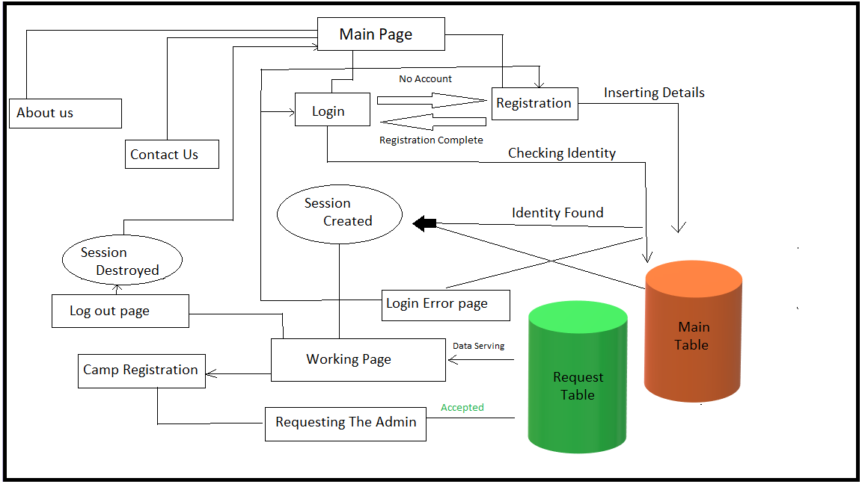

* 1. **Databases Design**



The above show the number of table used in database named as maindatabase.

The database contains two tables named as maintable and requesttable.

Table design

Main Table

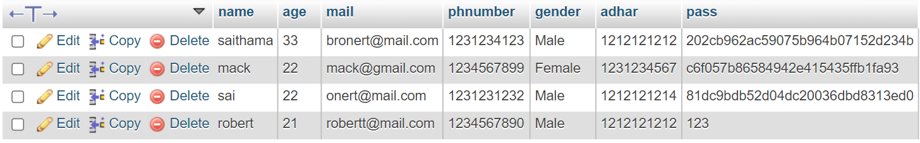

The above image is table that stores the user details that are inserted when someone registered in registration page.

Request Table



The above image is table that stores the campaigners details that are inserted when any user want to run campaign.

**4.technology used**

**4.1 Introduction:**

The website is developed by using HTML, CSS as front end

**4.2 Front End:**

**Html:**

Hypertext Markup Language (HTML) is standard markup language for creating web pages and web applications. With cascading style sheets(CSS), it forms a triad of cornerstone Technologies for the World Wide Web. Web browsers receive HTML documents from a Web server or from a web server or from local storage and render then into a multimedia Web pages. HTML describes the structures of a web page semantically and originally included cued for the appearances of the document.

HTML is the main markup language for web pages. HTML elements are the basic building-blocks of Web pages. HTML is written int the font of HTML elements consisting of tags enclosed in angle brackets like <html>, within the web pages Content. HTML tags most commonly come in pairs like <hl> and <h2>, although some tags, Imown as empty elements, are unpaired for example <image>.

Example elements:

1. <html>
2. <head>
3. <title>
4. <body>
5. <hl> to<h6>
6. <img src=” ”>
7. <table>
8. <a href=" "> . etc

**Cascading Styling:**

Cascading style Sheets, fondly referred to as CSS, is a simple design language intended to simplify the process of making web pages presentable.CSS handles the tool and feel part of a web page. Using CSS, you can control the color of the text, the style of fonts, the spacing between paragraphs , how columns arc sized and layout, what background images or colours are used, layout designs, variations in display for different devices and screen sizes as well as a variety of other effects.

OSS is easy to learn and understand but it provides powerful control over the presentation of an HTML document. Most commonly, CSS is combined with the markup languages HTML or XHTML. While the author of the document typically links that document to a CSS style sheet, readers can use a different style sheet, perhaps on their own computer, to override the one of the author has specified.

CSS specifies a priority scheme to determine which style rules apply if more than one rule matches against a particular element. In this so-called cascade, priorities or weights are calculated and assigned to rules, so that the results are predictable.

**CSS major properties:**

1. Color
2. Background—size, image, color
3. Font-family
4. Font size
5. Font weight
6. Transition
7. Transform
8. Perspective
9. Padding
10. Margin
11. Position
12. Border
13. Letter-spacing
14. Text-align
15. Z-index

**JavaScript:**

JavaScript is a prototype-based scripting language that is dynamic weakly typed and has first-class functions. It is a multi-paradigm language, supporting object-oriented, imperative, and functional programming styles.

JavaScript was finalized in the ECMA Script language standard and is primarily used in the form of client-side JavaScript, implemented as part of a Web browser in order to provide enhanced user interface and dynamic websites. This enables programming access to computational objects within a host environment.

JavaScript's use in application outside web pages for example in PDFD documents, site-specific browsers, and desktop widgets is also significant. Newer and faster JavaScript

VMS and frameworks built upon them (notably Node.js) have also increased the popularity of JavaScript for server-side web applications.

JavaScript uses syntax influenced by that of C. JavaScript copies many names and naming conversions form Java, but the two languages are otherwise unrelated and have very different semantics. The key design principles within JavaScript are taken from the self and Scheme programming languages.

**Back End:**

This web site is developed by using Amp Server,Xampp Server is a ination of PHP ,Apache and MySQL .This MySQL is used to organize data expected to be retained after a program terminates by providing procedure to store ,retrieve ,and update as well as manage the stored data .The most important purpose of a file system is to manage user data .This includes storing ,retrieving ,and updating data.

**5.CODING**

**Note:** It is not possible to keep all the codes so we wrote some code to the extent that our project can be understood.

1.Main page (index.php)

<!DOCTYPE html>

<html>

<head >

<meta name="viewport" content="width=device-width, initial-scale=1">

<link rel="stylesheet" href="https://cdnjs.cloudflare.com/ajax/libs/font-awesome/5.13.0/css/all.min.css">

<title>Life Host</title>

<style>

body{

margin: 0;

padding: 0;

font-family: poppins;

cursor: default;

}

header{

overflow: hidden;

height: inherit;

}

.vid-bg{

position: absolute;

right: 0;

bottom: 0;

min-height: 100%;

min-width: 100%;

}

.nav-area{

background: rgba(0,0,0,0.6);

height: 60px;

position: absolute;

width: 100%;

}

.menu-area{

float: right;

list-style: none;

margin: 20px;

}

.menu-area li{

display: inline-block;

margin: 0 5px;

}

.menu-area li a{

text-decoration: none;

color:white;

padding: 5px 5px;

letter-spacing: 2px;

font-size: 23px;

animation: glow 1s ease-in-out infinite alternate;

}

.menu-area li a .fas

{

color:white;

}

.menu-area li a:hover{

color :deepskyblue;

}

.banner-text{

position: absolute;

top: 50%;

left: 50%;

transform: translate(-50%,-50%);

text-align: center;

}

.banner-text h2{

color :white;

font-size: 40px;

margin: 0;

}

.banner-text p{

color :white;

font-size: 18px;

margin: 0;

font-weight: bold;

}

.btn{

display: inline-block;

margin-top: 5%;

background: transparent;

border: 0;

font-size: 20px;

text-transform: uppercase;

border:3px solid white;

padding: 10px 25px;

color:white;

border-radius: 25px;

width:50%;

}

.btn:hover

{

transform: 0.3s;

background-color: black;

font-size: 24px;

color:deepskyblue;

border-color:deepskyblue;

animation: glow 1s ease-in-out infinite alternate;

}

.nar{

float: inherit;

}

.nar a{

text-decoration: none;

color :white;

}

.glow {

margin: 0 50px;

height: 60px;

color:white;

font-size: 35px;

text-transform: capitalize;

font-weight: bold;

letter-spacing: 2px;

float: left;

padding: 13px 0;

animation: glow 1s ease-in-out infinite alternate;

}

@-webkit-keyframes glow {

from {

text-shadow: 0 0 10px deepskyblue, 0 0 20px deepskyblue, 0 0 30px deepskyblue, 0 0 40px deepskyblue ;

}

to {

text-shadow: 0 0 20px skyblue, 0 0 30px skyblue, 0 0 40px skyblue, 0 0 50px skyblue;

}

}

</style>

<script>

function servicesec()

{

alert("Service section is under development");

}

</script>

</head>

<body>

<header>

<video src="PixelFiles/Videos/planefloat2.mp4" class="vid-bg" autoplay loop muted></video>

<div class="nav-area">

<div class="glow">Life Host</div>

<ul class="menu-area">

<li><a href="aboutus.html" title="Aboutus"><i class="fas fa-info-circle"></i></a></li>

<li><a href="contactus.html" title="Click To Contact"><i class="fas fa-envelope"></i></a></li>

</ul>

</div>

<div class="banner-text">

<h2 class="glow">The World Need your help</h2>

<div class="nar">

<a href="index.php" class="btn">Go</a>

</div>

</div>

</header>

</body>

</html>

Login page (Login.html)

<html>

<head>

<meta charset="utf-8">

<meta name="viewport" content="width=device-width, initial-scale=1">

<title>Login Form</title>

<style>

body{

margin: 0;

padding: 0;

font-family: sans-serif;

height:100%;

background-size: cover;

cursor: default;

}

.contactForm

{

width: 40%;

padding: 40px;

background:black;

border-radius: 25px;

margin: 0 auto;

margin-top: 7%;

border: 3px solid deepskyblue;

}

.contactForm h2

{

text-align: center;

margin-bottom: 10px;

font-size: 25px;

padding: 13px 0;

color:white;

text-align: center;

animation: glow 1s ease-in-out infinite alternate;

}

.contactForm .inputBox

{

position: relative;

width: 100%;

margin-top: 10px;

}

.contactForm .inputBox input,

.contactForm .inputBox textarea

{

width: 100%;

padding: 5px 0;

font-size: 16px;

margin: 10px 0;

border: none;

border-bottom: 2px solid #333;

outline: none;

resize: none;

color:white;

background-color: transparent;

}

.contactForm .inputBox span

{

position: absolute;

left: 0;

padding: 5px 0;

font-size: 16px;

margin: 10px 0;

pointer-events: none;

transition: 0.2s;

color: deepskyblue;

}

.btn{

width: 100%;

background: none;

border: 2px solid deepskyblue;

color: deepskyblue;

padding: 1%;

font-size: 18px;

cursor: pointer;

margin: 12px 0;

margin-bottom: 0.4%;

border-radius:25px;

}

.btn:hover{

transition: 0.4s;

width: 100%;

background: black;

border: 2px solid deepskyblue;

color: deepskyblue;

cursor: pointer;

margin: 12px 0;

margin-bottom: 0.4%;

border-radius:25px;

animation: glow 1s ease-in-out infinite alternate;

}

.vid-bg{

position:fixed;

right: 0;

bottom: 0;

min-height: 100%;

min-width: 100%;

z-index: -1;

}

.glow {

margin-top: auto;

float: left;

font-size: 40px;

padding: 13px 0;

color:white;

text-align: center;

animation: glow 1s ease-in-out infinite alternate;

}

@-webkit-keyframes glow {

from {

text-shadow: 0 0 10px #fff, 0 0 20px #fff, 0 0 30px deepskyblue, 0 0 40px deepskyblue, 0 0 50px deepskyblue, 0 0 60px deepskyblue, 0 0 70px deepskyblue;

}

to {

text-shadow: 0 0 20px #fff, 0 0 30px skyblue, 0 0 40px skyblue, 0 0 50px skyblue, 0 0 60px skyblue, 0 0 70px skyblue, 0 0 80px skyblue;

}

}

span

{

transform: translateY(-30px);

animation: glow 1s ease-in-out infinite alternate;

}

</style>

<script>

function validform()

{

var email=document.getElementById("nmael");

var pass=document.getElementById("passl");

var valid=true;

var filtration=/^([a-z A-Z 0-9_\.-]+)@(([a-z A-Z 0-9\-])+).([a-z A-Z0-9] {2,8})?$/;

if((filtration.test(email.value)) || (email.value.trim()==""))

{

email.style="color:red;";

}

else

{

email.style="color :green;";

}

if(pass.value.trim()=="" )

{

pass.style="border-bottom:1px solid red";

pass.placeholder="Incorrect password";

valid= false;

}

else

{

pass.style="border-bottom:1px solid green";

}

if(!valid)

{

alert("Enter the details correctly");

}

return valid;

}

function logv()

{

document.getElementById("visbl").style="visibility:visible";

}

function validname()

{

var email=document.getElementById("namel");

const pattern=/^[^ ]+@[^ ]+\.[a-z]{2,3}$/

if(email.value.match(pattern))

email.style="color:lime;";

else

email.style="color:#ff3300;";

}

</script>

</head>

<body>

<video src="PixelFiles/Videos/planedot.mp4" class="vid-bg" autoplay loop muted></video>

<div class="contactForm">

<form action="Loginphp.php" method="post">

<h2>Login</h2>

<div class="inputBox">

<input type="text" required="required" id="namel" name="namel" onkeypress="validname();">

<span>Mail</span>

</div>

<div class="inputBox">

<input type="password" required="required" name="passl" onkeypress="logv();">

<span>password</span>

</div>

<button type="submit" class="btn" id="visbl" style="visibility:hidden">Login</button>

</form>

<a href="Registration.html"><button class="btn">No Account</button></a>

</div>

</body>

</html>

Login page(Loginphp.php)

<?php

session_start(); // Starting Session

$error=''; // Variable To Store Error Message

if (empty($_POST['namel']) || empty($_POST['passl'])) {

}

else

{

// Define $username and $password

$mail=$_POST['namel'];

$password=$_POST['passl']; password as a parameter

$connection = mysqli_connect("localhost:3306", "root", "","maindatabase");

// To protect MySQL injection for Security purpose

$username = stripslashes($mail);

$password = stripslashes($password);

$username = mysqli_real_escape_string($connection,$mail);

$password = mysqli_real_escape_string($connection,$password);

$query = mysqli_query($connection,"select * from maintable where pass='$password' AND mail='$mail'");

$conne = mysqli_connect("localhost:3306", "root", "","maindatabase");

$rows = mysqli_num_rows($query);

if ($rows == 1) {

$_SESSION['login_user']=$mail; // Initializing Session

header("location: list.php"); // Redirecting To Other Page

}

elseif($mail=="WebsiteAdmin@mail.com" and $password=="1915103040")

{

$_SESSION['login_user']=$mail; // Initializing Session

header("location: Master.php");

}

else {

echo "<center><h1>Username or Password is invalid</h1></center>";

header("location: Loginerror.html");

echo $rows;

}

mysqli_close($connection); // Closing Connection

}

?>

Registration page(Registration.html) <!DOCTYPE html>

<html>

<head>

<meta charset="utf-8">

<meta name="viewport" content="width=device-width, initial-scale=1">

<link href="https://stackpath.bootstrapcdn.com/font-awesome/4.7.0/css/font-awesome.min.css"rel="stylesheet">

<link rel="stylesheet" href="Registrationcss.css">

<title>Registration Form</title>

<script>

function validform()

{

var name=document.getElementById("name");

var pass=document.getElementById("pass");

var pass1=document.getElementById("pass1");

var uage=document.getElementById("age");

var email=document.getElementById("mail");

var num=document.getElementById("num");

var valid=true;

if(name.value.trim()=="" )

{

name.style="border-bottom:2px solid red;";

name.placeholder="Incorrect Username";

name.value="";

valid= false;

}

else

{

name.style="border-bottom-color :green;";

}

if(pass1.value!=pass.value )

{

pass1.style="border-bottom-color :red;";

pass1.value="";

pass1.placeholder="Mismatched password";

valid= false;

}

else

{

pass1.style="border-bottom-color :green;";

}

if(pass.value.trim()=="" )

{

pass.style="border-bottom-color :red;";

pass1.style="border-bottom-color :red;";

pass.placeholder="Incorrect password";

pass.value="";

valid= false;

}

else

{

pass.style="border-bottom-color :green;";

pass1.style="border-bottom-color :green;";

}

if(!(num.value.toString().length==10))

{

num.style="border-bottom-color :red;";

num.value="";

num.placeholder="Invalid number";

valid= false;

}

else

{

num.style="border-bottom-color :green;";

}

var filtration=/^([a-z A-Z 0-9_\.-]+)@(([a-z A-Z 0-9\-])+).([a-z A-Z0-9] {2,8})?$/;

if((filtration.test(email.value)) || (email.value.trim()==""))

{

email.style="border-bottom-color:red;";

email.value="";

email.placeholder="Invalid Email Address";

valid= false;

}

else

{

email.style="border-bottom-color :green;";

}

if(uage.value<18 )

{

uage.style="border-bottom-color :red;";

alert("Age should be above 18");

return false;

}

else

{

uage.style="border-bottom-color :green;";

}

if(!valid)

{

alert("Enter the details correctly");

}

else{

alert("Remember the password");

}

return valid;

}

</script>

</head>

<body>

<video src="PixelFiles/Videos/planedot.mp4" class="vid-bg" autoplay loop muted></video>

<div class="login-box" style="margin:3% 15%; background-color: black;">

<form class="login-form" method="post" onsubmit="return validform()" action="Registerphp.php">

<h1 class="glow">Registration</h1>

<div class="textbox">

<input id="name" type="text" placeholder="Name" name="name"required>

</div>

<div class="textbox">

<input id="age" name="age" type="text" placeholder="Age (should be 18+)" required>

</div>

<div class="textbox">

<input id="mail" type="email" placeholder="Gmail" name="mail" required>

</div>

<div class="textbox">

<input id="num" name="num" type="text" placeholder="Number" required/></div>

<select id=gender style="background-color:transparent; color:deepskyblue; width:100%" name="gender">

<option value="Male" style="background-color:transparent; color:deepskyblue;">Male</option>

<option value="Female" style="background-color:transparent; color:deepskyblue;">Female</option>

<option value="Female" style="background-color:transparent;color:deepskyblue;">Transgender</option>

<option value="Gender" style="background-color:transparent;color:deepskyblue;" SELECTED>Gender</option>

</select>

<div class="textbox">

<input id="adhar" type="text" placeholder="Aadhaar Number (optional)" name="adhar" >

</div>

<div class="textbox">

<input id="pass" name="pass" type="password" placeholder="Password" required>

</div>

<div class="textbox">

<input id="pass1" type="password" placeholder="Confirm Password" required>

</div> <input type="submit" class="btn" value="Register Now">

</form>

<a href="Login.html" ><button class="btn">Login</button></a>

</div>

</body>

</html>

Rgistration page (registrationphp.php**)**

<style>

.btn{

display: inline-block;

margin-top: 5%;

background: transparent;

border: 0;

font-size: 20px;

text-transform: uppercase;

border:3px solid white;

padding: 10px 25px;

color:white;

border-radius: 25px;

}

</style>

<?php

$name = $_POST['name'];

$age= $_POST['age'];

$mail= $_POST['mail'];

$num= $_POST['num'];

$gender= $_POST['gender'];

$adhar= $_POST['adhar'];

$pass= $_POST['pass'];

if (empty($adhar))

{

$adhar="Empty";

}

$servername="localhost:3306";

$username="root";

$password="";

$database="maindatabase";

$conn=mysqli_connect($servername,$username,$password,$database);

if (!$conn) {

die("Connection failed: " . mysqli_connect_error());

}

else

{

$sql="insert into maintable values('$name','$age','$mail','$num','$gender','$adhar','$pass');";

if(mysqli_query($conn,$sql))

{

$name = stripslashes($name);

$name = mysqli_real_escape_string($connection,$name);

$age = stripslashes($age);

$age = mysqli_real_escape_string($connection,$age);

$mail = stripslashes($mail);

$mail = mysqli_real_escape_string($connection,$mail);

$num = stripslashes($num);

$num = mysqli_real_escape_string($connection,$num);

$age = stripslashes($age);

$age = mysqli_real_escape_string($connection,$age);

$adhar = stripslashes($adhar);

$adhar = mysqli_real_escape_string($connection,$adhar);

$pass = stripslashes($pass);

$pass = mysqli_real_escape_string($connection,$pass);

echo '<center style="font-size:20px;border:3px solid deepskyblue;">Registration is succesfull , Loading Login Page<center>';

header("Location: Login.html");

}

else

{

echo "<h2><center>Multiple Atributes Are Found In Same Mail ,Please Enter New Mail</center></h2>";

}

mysqli_close($conn);

}

?>

About Us (aboutus.html)

<!DOCTYPE html>

<html lang="en">

<head>

<meta charset="UTF-8">

<meta name="viewport" content="width=device-width, initial-scale=1">

<link href="https://stackpath.bootstrapcdn.com/font-awesome/4.7.0/css/font-awesome.min.css"rel="stylesheet">

<title>Our Team Section</title>

<style>

@import url('https://fonts.googleapis.com/css?family=Allura|Josefin+Sans');

*{

margin: 0;

padding: 0;

box-sizing: border-box;

}

body{

font-family: 'Josefin Sans', sans-serif;

cursor: default;

}

.wrapper{

margin-top: 5%;

}

h1{

color :white;

font-size: 52px;

margin-bottom: 60px;

}

.team{

display: flex;

justify-content: center;

width: auto;

text-align: center;

flex-wrap: wrap;

}

.team .team_member{

background:rgba(0,0,0,0.6);

margin: 5px;

margin-bottom: 50px;

width: 300px;

padding: 20px;

line-height: 20px;

color: white;

position: relative;

border: 2px solid deepskyblue;

border-radius: 25px;

}

.team .team_member:hover{

background:black;

cursor: default;

margin: 5px;

margin-bottom: 50px;

width: 300px;

padding: 20px;

line-height: 20px;

color: white;

position: relative;

border: 1px solid white;

border-radius: 25px;

border: 2px solid deepskyblue;

animation: glow 1s ease-in-out infinite alternate;

}

.team .team_member h3{

color: #81c644;

font-size: 26px;

margin-top: 50px;

color:white;

text-transform: capitalize;

font-weight: bold;

padding: 13px 0;

animation: glow 1s ease-in-out infinite alternate;

}

.team .team_member p.role{

color: #ccc;

margin: 12px 0;

font-size: 12px;

text-transform: uppercase;

}

.team .team_member .team_img{

position: absolute;

top: -50px;

left: 50%;

transform: translateX(-50%);

width: 100px;

height: 100px;

border-radius: 50%;

background: transparent;

}

.team .team_member .team_img img{

width: 100px;

height: 100px;

padding: 5px;

border-radius:50%;

}

.floatit img{

float:right;

left: 0%;

padding: 5%;

}

.vid-bg{

position:fixed;

right: 0;

bottom: 0;

min-height: 100%;

min-width: 100%;

}

@-webkit-keyframes glow {

from {

text-shadow: 0 0 10px deepskyblue, 0 0 20px deepskyblue;

}

to {

text-shadow: 0 0 20px skyblue, 0 0 30px skyblue;

}

}

</style>

</head>

<body>

<video src="PixelFiles/Videos/planedot.mp4" class="vid-bg" autoplay loop muted></video>

<h1>Our Team</h1>

<div class="wrapper">

<div class="team">

<div class="team_member">

<div class="team_img">

<img src="PixelFiles/Images/default.jpg" alt="Team_image">

</div>

<h3 class="glow">Sathwik </h3>

<p class="role">Backend developer</p>

<p>19001-CM-227</p>

<p>Studying in masabtank hyd</p>

<center><div class="floatit">

<img src=""/>

<img src=""/>

<img src=""/>

</div></center>

</div>

<div class="team_member">

<div class="team_img">

<img src="PixelFiles/Images/back1.jpg" alt="Team_image">

</div>

<h3>Akash</h3>

<p class="role">Frontend developer</p>

<p>19001-CM-001</p>

<p>Studying in masabtank hyd</p>

</div>

<div class="team_member">

<div class="team_img">

<img src="PixelFiles/Images/default.jpg" alt="Team_image">

</div>

<h3>Nikhil</h3>

<p class="role">Webpage Animation developer</p

<p>19001-CM-223</p>

<p>Studying in masabtank hyd</p>

</div>

<div class="team_member">

<div class="team_img">

<img src="PixelFiles/Images/back.png" alt="Team_image">

</div>

<h3>Shiva</h3>

<p class="role">Frontend Developer</p>

<p>19001-CM-259</p>

<p>Studying in masabtank hyd</p></div>

<div class="team_member">

<div class="team_img">

<img src="PixelFiles/Images/sai.jpg" alt="Team_image">

</div>

<h3>Sai Krishna </h3>

<p class="role">webpage Supporter</p>

<p>19001-CM-222</p>

<p>Studying in masabtank hyd</p>

</div>

</div>

</div>

</body>

</html>

Campaigners list(list.php)

<html>

<head>

<title>Donate it</title>

<link rel="stylesheet" href="https://cdnjs.cloudflare.com/ajax/libs/font-awesome/5.13.0/css/all.min.css">

<style>

*{

color:white;

}

.block{

margin-bottom: 0.5%;

height:inherit;

width:auto;

padding: 4%;

border: 1px solid deepskyblue;

background: rgba(0,0,0,0.4);

}

.block img{

margin: 0 40%;

border-radius: 20%;

background: transparent;

border: 3px solid black;

}

.block p {

margin: auto;

margin-right: 12%;

color :white;

font-size:100%;

}

.vid-bg{

z-index: -1;

position:fixed;

right: 0;

bottom: 0;

min-height: 100%;

min-width: 100%;

}

.nav-area{

background: rgba(0,0,0,0.7);

height: 60px;

width: 100%;

margin-bottom: 1.5%;

border-bottom:2px solid skyblue;

}

.menu-area{

float: right;

list-style: none;

}

.menu-area li{

display: inline-block;

margin: 0 5px;

}

.menu-area li a{

text-decoration: none;

color:white;

padding: 5px 10px;

letter-spacing: 2px;

font-size: 23px;

animation: glow 1s ease-in-out infinite alternate;

}

.menu-area li a:hover{

animation: glow 1s ease-in-out infinite alternate;

}

.glow {

margin: 0 50px;

height: 60px;

color:white;

font-size: 35px;

text-transform: capitalize;

font-weight: bold;

letter-spacing: 2px;

float: left;

padding: 13px 0;

animation: glow 1s ease-in-out infinite alternate;

}

@-webkit-keyframes glow {

from {

text-shadow: 0 0 10px deepskyblue, 0 0 20px deepskyblue, 0 0 30px deepskyblue, 0 0 40px deepskyblue, 0 0 50px deepskyblue, 0 0 60px deepskyblue, 0 0 70px deepskyblue;

}

to {

text-shadow: 0 0 20px skyblue, 0 0 30px skyblue, 0 0 40px skyblue, 0 0 50px skyblue, 0 0 60px skyblue, 0 0 70px skyblue, 0 0 80px skyblue;

}

}

</style>

</head>

<body style="cursor:default">

<video src="PixelFiles/Videos/planedot.mp4" class="vid-bg" autoplay loop muted></video>

<div class="nav-area">

<div class="glow">Life Host</div>

<ul class="menu-area">

<li onclick="alert('Are You Want To Run Campaign')"><a href="RunCamp.php"><i class="far fa-registered" title="Run Campaign"></i></a></li>

<li><a href="Logout.php" title="Log Out"><i class="fas fa-sign-out-alt"></i></a></li>

</ul>

</div>

<?php

$connection = mysqli_connect("localhost:3306", "root","","maindatabase");

session_start();// Starting Session

// Storing Session

$user_check=$_SESSION['login_user'];

// SQL Query To Fetch Complete Information Of User

$res=mysqli_query($connection,"select * from requesttable");

if(isset($user_check))

{

for($i=1;$i<=mysqli_num_rows($res);$i++)

{

$row=mysqli_fetch_array($res);

if($row['state']=="accepted"){

?>

<div class="block">

<img src="PixelFiles/profile/<?=$row['profile']?>" height="100px"/>

<p><?=$row['rmessage']?><details><summary style="color:deepskyblue;">MORE</summary><h4><?=$row['vmessage']?><br/>

Payment : <?=$row['payment']?> Number <?=$row['paynumber']?>

<br/>

Witness Phone Number: <?=$row['wnumber']?>

</h4></details>

</p></div>

<?php

}

}

} ?>

</body>

</html>

Admin control page(Master.php)

<html>

<head>

<title>Admin Privilages</title><link rel="stylesheet" href="https://cdnjs.cloudflare.com/ajax/libs/font-awesome/5.13.0/css/all.min.css">

<style>

*{

color:white;

}

.block{

margin-bottom: 0.5%;

height:inherit;

width:auto;

padding: 4%;

border: 2px solid orangered;

background: rgba(0,0,0,0.4);

}

.block img{

margin: 0 45%;

border-radius: 20%;

background: transparent;

border: 2px solid orangered;

}

.block p {

margin: auto;

margin-right: 12%;

color :white;

font-size:100%;

}

.vid-bg{

z-index: -1;

position:fixed;

right: 0;

bottom: 0;

min-height: 100%;

min-width: 100%;

}

.nav-area{

background: rgba(0,0,0,0.7);

height: 60px;

width: 100%;

margin-bottom: 1.5%;

border-bottom:2px solid orangered;

}

.menu-area{

float: right;

list-style: none;

}

.menu-area li{

display: inline-block;

margin: 0 5px;

}

.menu-area li a{

text-decoration: none;

color:white;

padding: 5px 10px;

letter-spacing: 2px;

font-size: 23px;

animation: glow 1s ease-in-out infinite alternate;

}

.menu-area li a:hover{

color:deepskyblue;

animation: glow 1s ease-in-out infinite alternate;

}

.glow {

margin: 0 50px;

height: 60px;

color:white;

font-size: 35px;

text-transform: capitalize;

font-weight: bold;

letter-spacing: 2px;

float: left;

padding: 13px 0;

animation: glow 1s ease-in-out infinite alternate;

}

@-webkit-keyframes glow {

from {

text-shadow: 0 0 10px orangered, 0 0 20px orangered, 0 0 30px orangered, 0 0 40px orangered, 0 0 50px orangered, 0 0 60px orangered, 0 0 70px orangered;

}

to {

text-shadow: 0 0 20px orangered, 0 0 30px orangered, 0 0 40px orangered, 0 0 50px orangered, 0 0 60px orangered, 0 0 70px orangered, 0 0 80px orangered;

}

}

.submm

{

background-color: orangered;

color: black;

padding: 1%;

width:50%;

}

.submm:hover

{

background-color: black;

color: orangered ;

padding: 1%;

width:50%;

}

.tex

{

color:orangered;

}

</style>

</head>

<body style="cursor:default">

<video src="PixelFiles/Videos/planedot.mp4" class="vid-bg" autoplay loop muted></video>

<div class="nav-area">

<div class="glow">Admin</div>

<ul class="menu-area">

<li><a href="aboutus.html"></a></li>

<li><a href="Logout.php" title="Log Out"><i class="fas fa-sign-out-alt"></i></a></li>

</ul>

</div>

<?php

$connection = mysqli_connect("localhost:3306", "root","","maindatabase");

session_start();// Starting Session

// Storing Session

$user_check=$_SESSION['login_user'];

// SQL Query To Fetch Complete Information Of User

$res=mysqli_query($connection,"select * from requesttable");

if(isset($user_check))

{

for($i=1;$i<=mysqli_num_rows($res);$i++)

{

$row=mysqli_fetch_array($res);

?>

<div class="block">

<img src="PixelFiles/profile/<?=$row['profile']?>" height="100px"/><br/><br/>

<?php

if($row['state']=="accepted")

{ ?>

<center><b style="color:lime">ACCEPTED</b></center>

<?php }

if($row['state']=="declined")

{?>

<center><b style="color:red">DECLINED</b></center>

<?php

}

?><br/>

<p><?=$row['rmessage']?> <details><summary style="color:orangered;">MORE</summary><h4>

<img src="PixelFiles/profile/<?=$row['victim']?>" height="70px"/><br/><?=$row['vmessage']?><br/>

Payment : <?=$row['payment']?> Number <?=$row['paynumber']?>

<br/>

Witness Phone Number: <?=$row['wnumber']?><br/><br/>

Aadhaar : <?=$row['aadhar']?> <br/><br/>

<form action="Master.php" method="post">

<input type="radio" id="agree" name="on" value="Agree" style="color:lime;"><span style="color:green;">Accept Request</span><br/>

<input type="radio" id="agree" name="on" Value="Disagree"><span style="color:red;">Decline Request</span><br/>

<input type="text" value="<?=$row['mailaddr']?>" name="nobr" hidden>

<center><button type="sumbit" value="submit" name="submit" class="submm">Submit</button></center>

</form>

</h4></details>

</p></div>

<?php

}

}

if($_POST){

$mailt=$_POST['nobr'];

if($_POST)

{

if ($_POST['on']=="Agree")

{

mysqli_query($connection,"update requesttable set state = 'accepted' where mailaddr='$mailt' ; ");

}

else

{

mysqli_query($connection,"update requesttable set state = 'declined' where mailaddr='$mailt'; ");

}

}

}

?>

</body>

</html>

**6. SYSTEM TESTING AND IMPLEMENTATION**

**6.1 Introduction :**

A level of software testing is a process where every unit or component of a software/system is tested. The main goal of system testing is to evaluate the system's compliance with the specified needs.

There are many different testing levels which help to check behavior and performance for software testing. ese testing levels are designed to recognize missing areas and reconciliation between the development lifecycle states. In SDLC models there are characterized phases such as requirement gathering, analysis, design, coding or execution, testing, and deployment.

Software Testing:

Software testing is the process of evaluation a software item to detect differences between given input and expected output. Also to assess the feature of A software item. Testing assesses the quality of the product. Software testing is a process that should be done during the development process. In other words software testing is a verification and validation process.

Verification :

Verification is the process to make sure the product satisfies the conditions imposed at the start of the development phase. In other words, to make sure the product behaves the way we want it to.

Validation :

Validation is the process to make sure the product satisfies the specified requirements at the end of the development phase. In other words, to make sure the product is built as per customer requirements.

**6.2 Testing Methods :**

The Box Approach:

Software testing methods are traditionally divided into white Box Testing & Black Box Testing these two approaches are used to describe the point of view of the test engineer, when hr is assigned with an application to test and design the test cases. WHITE BOX TESTING APPROACH:

White Box Testing :

Transparent Box Testing, and Structure Testingtests internal structures of the application or working of a program.In White Box Testing, an internal perspective of the system as well as programming skills is used to design test cases. While White box testing can be applied at unit, integrated levels of the system, it is generally preferred to be done at unit level.

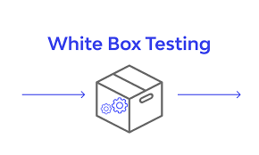

Black Box testing :

This type of testing approach is mostly preferred, as it is the most convenient type of software Testing. Here the entire Software product is taken as a single component, i.e. a Black Box, and then its functionality is tested without any knowledge of its internal implementation. The person testing has to be aware what the application is supposed to do, but not how it does what t is supposed to do.

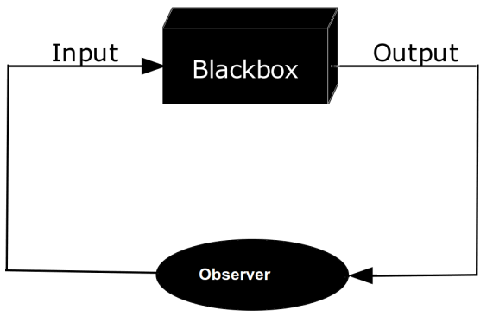

Gray Box Testing :

The most sophisticated and complicated way of Software Testing is the Grey Box Testing. This testing method involves checking, which needs knowledge of the entire internal data structure and algorithms hired to develop that particular application. Once known, those components are taken either at Black or White Level again, and are tested by the assigned tester. The advantages of this level of testing is that the tester is not required to have access to full source of the software he is testing Only handling him the algorithms and implementation details will do the work. In general it is the combination of Black box and white box testing

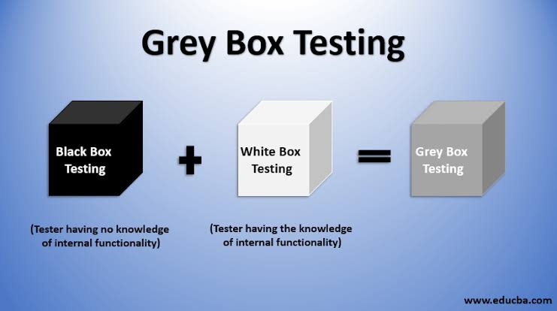

**7.SCREENSHOTS**

**Main page(index.html)**

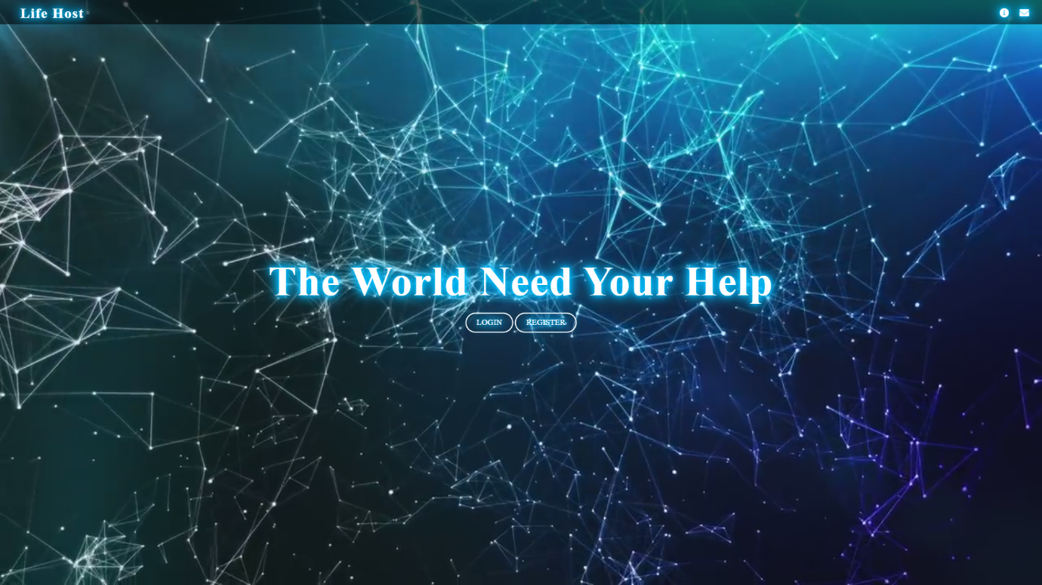

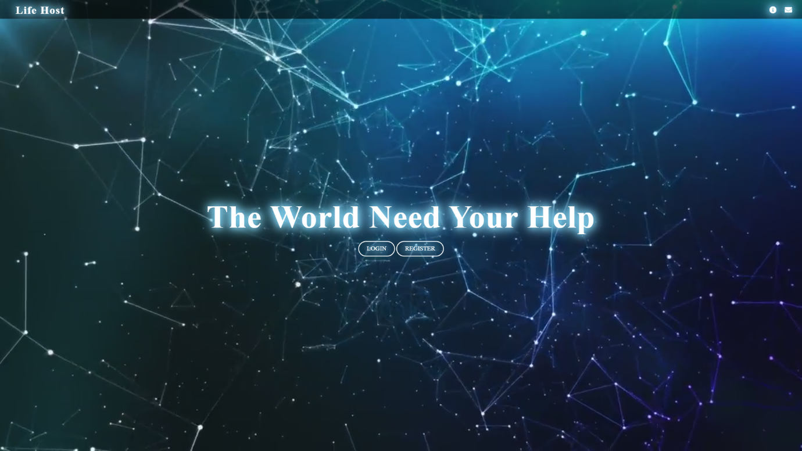

The above page is main page this is starting page of our website .

This is website is shown if you are new user , this is because the session is not yet created .

The session is crested when user login to website , and start the above page.

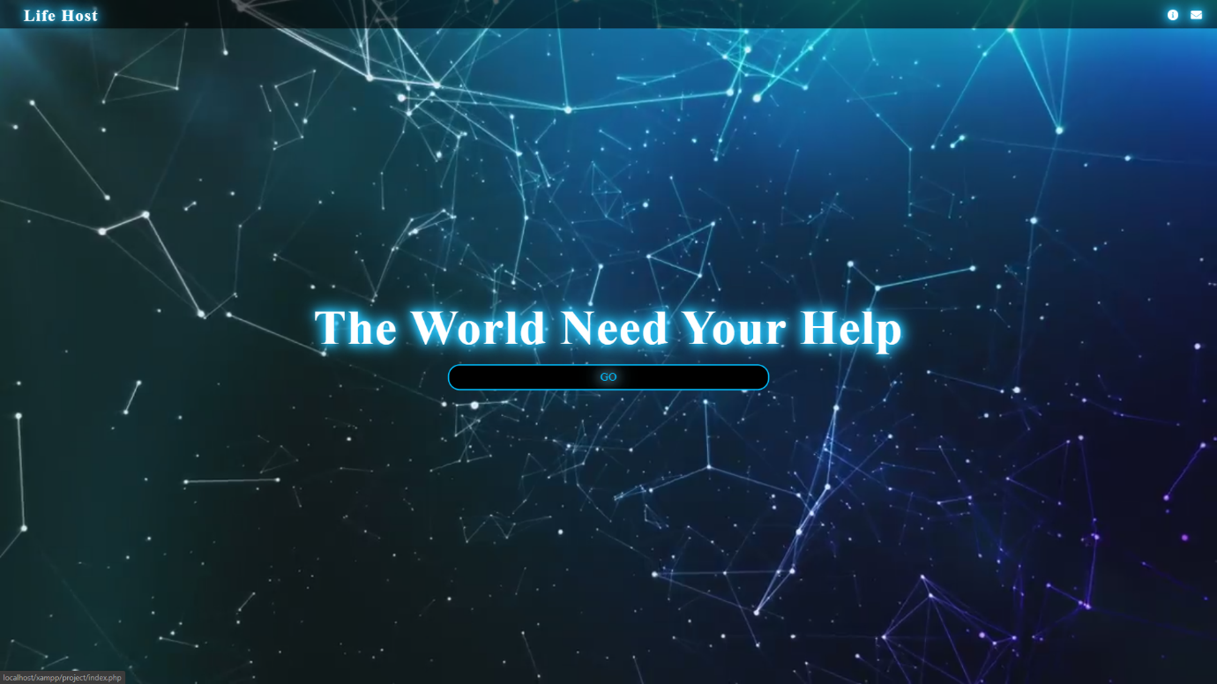

This above page is also main page shown when session is created that is when user login to website and starts the main page.

**Login page(Login.html)**

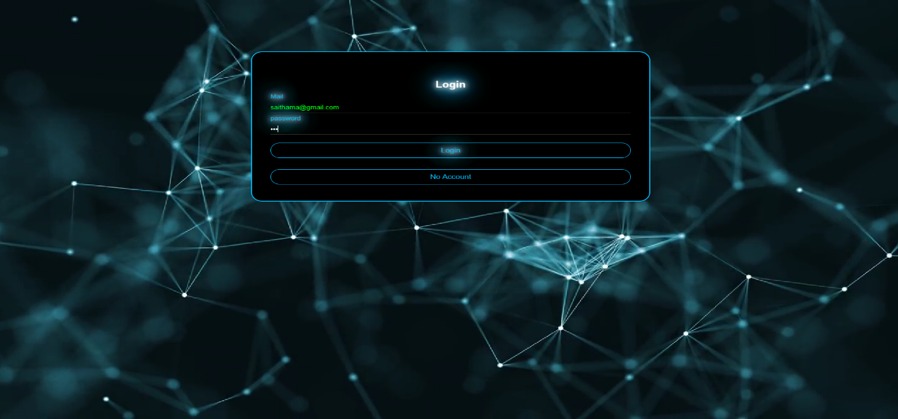

The above page is login page that is used for the user to start the session and use the website.

**Registration page**

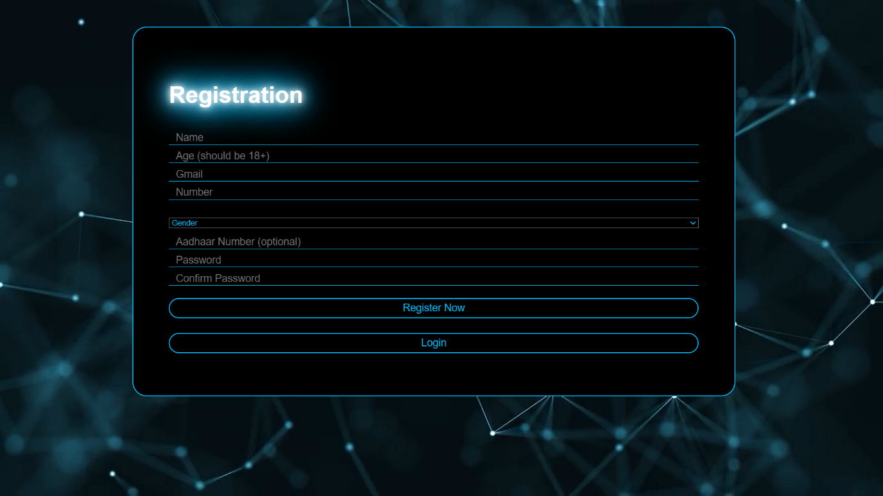

The above page is registration page , when any user wants to login the website , he has to register to the page.

**About us(about.html)**

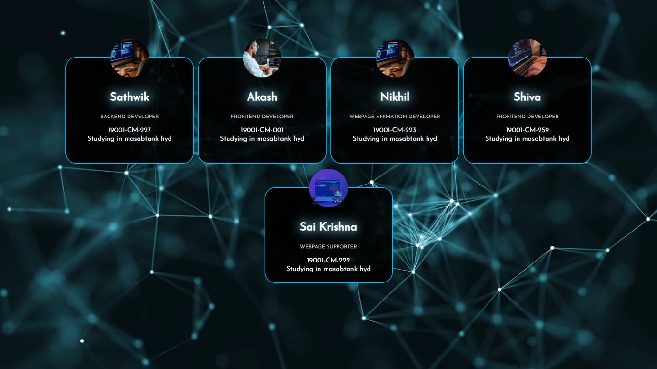

The above page shows the details of one who contributed in developing this website.

**8.FUTURE ENCHANCMENT**

In the present working project are few drawbacks to increase the efficiency of the project for future implement the following:

**8.1 Limitations of existing system:**

* There is no particular legal or trusted website for social services.
* Mainly there is no proper features to identify ID whether the existing one is real or fake.
* No proper security for transections and it may lead to hack your credentials info.
* Less user interactive and no proper guides or custom services.

**8.2 Proposed System:**

So we took initiative to develop a website for our social services and over come from all above limitations following are few features.

* This website is easy to interact for user and easy to communicate with website admins through mails.
* Developed by the intention of removing fake identities.
* Developed to stop special attack called SQL injection.
* Online payments are accepted if and only user provide his number or QR CODE SCANNER.

**8.3 Future Goals:**

* We will also try to deploy our website in internet.
* We will increase the security in protecting the passwords and other through sha256 hashing algorithm.
* We will try available in software and android applications.
* We will try to get the SSL certificate to enhance the security.
* We will try to make our website to available all types of UPI payments.

**9.CONCLUSION**

This is how our Project Work comes to an end. Coming into the conclusion part, we feel so happy for making our porotype a successful working one. Each and every person in our entire team learnt a lot working with this project. Some of the things we came to know the importance of working a team and the importance of team co-ordination as well. We came to know that it is not possible with a single person to take up the complete work load and this is where we learnt the group formation.

We even learnt how to manage all the things in time an effective output. In short we got to know the complete working environment of a software industry. On this note, we hope that this simply is a starting point for our young carrier and a successful submission of this working we feel, and after completion of this project we all came to know how the website or an web application or a software products will be developed, and what are the criteria it have to follow to obtain an effective result and how a software project will be completed.

We followed the Time Management techniques and successfully completed the project in time and submitted it to our faculty along with this documentation report. Programming is fun while we write a code for something then we will learn a lot for not only a particular thing and it leads to changes our plans. At last we all became the “SUCCESSFULL PROGRAMMERS”.

**10.BIBLIOGRAPHY**

Bibliography generally refers to the references used for designing developing & implementing the system. Bibliography can be one the useful resource, when documentation is taken into consideration. The Bibliography for this particular system can include the following references.

**References:**

1. [**https://milaap.org/**](https://milaap.org/)
2. [**https://milaap.org/about-us/overview**](https://milaap.org/about-us/overview)